RINGS-EUR-Italy-Rome- Legio II Augusta

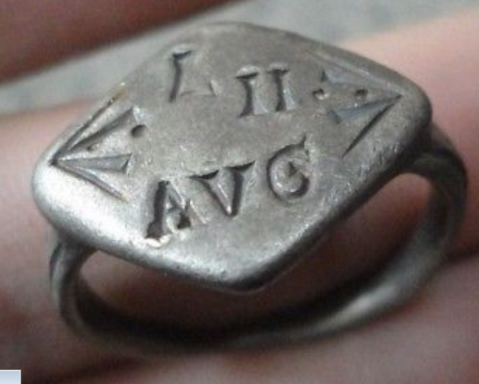

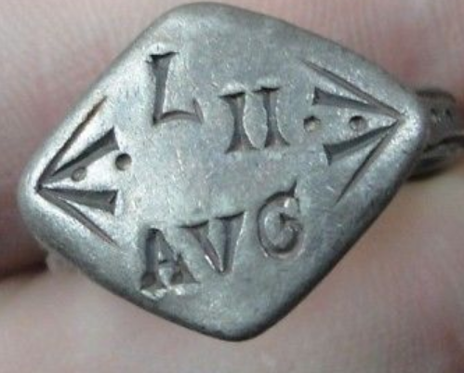

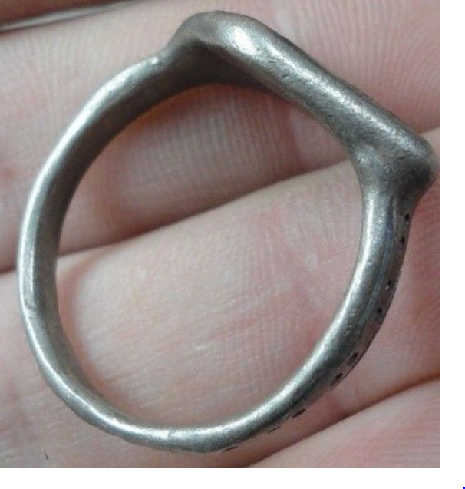 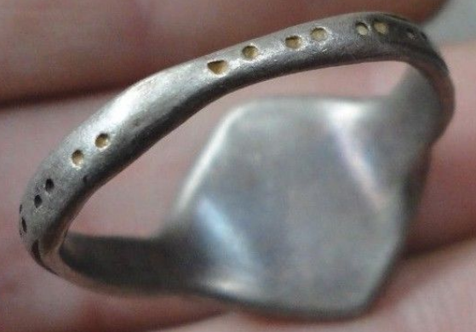 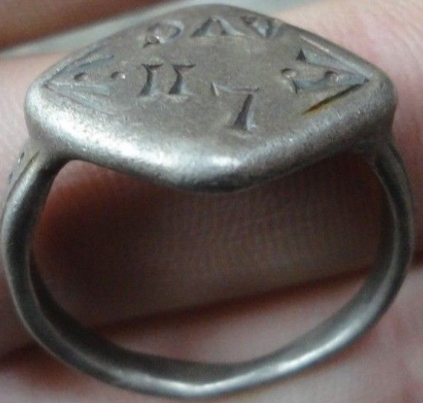 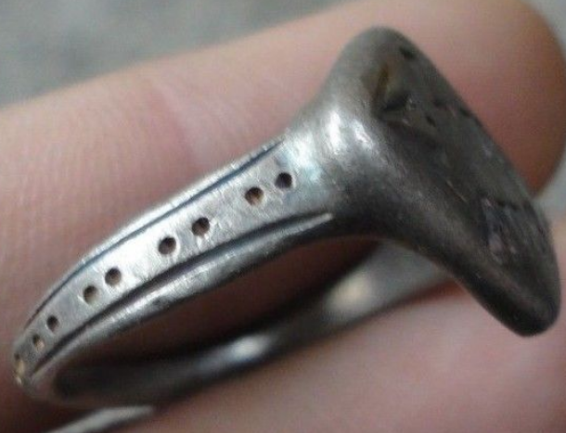 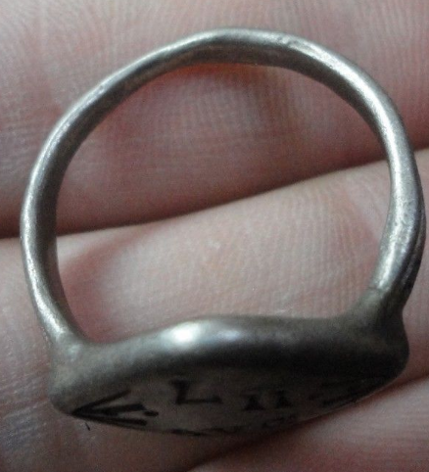

Legio II Augusta

**Legio secunda Augusta ("Augustus' Second Legion") was a legion of the Imperial Roman army that was founded during the late Roman republic.**

INSCRIBED - " AVG - L - II "

EXTREMELY RARE **Roman SENATORIAL LEGIONARY SILVER ring.**

SOLID SILVER - Wearable <> 8.64 grams <>

**<> 22.00mm. = 0.88" Inner diameter <>**

Silver, I purchased this item as an ancient Roman relic but have no papers with the item, so bid at your own discretion !!! If you have second thoughts, please do not bid. I checking the item by EXPERT on determining the composition of the metal and it is 100% SILVER and Silver have 100 % authentic GENUINE OLD PATINA.This is a unique item that does not repeat itself.